A5-1.1 Data Anomalies
Consider the following form:
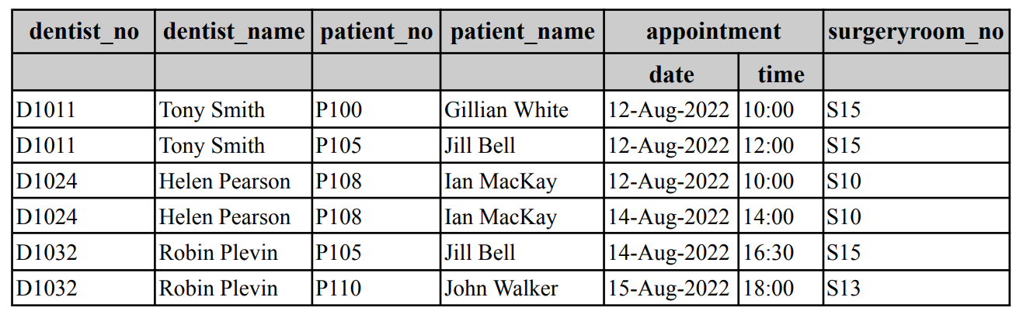
This form shows the details about dental surgery appointments. What possible insert, update and delete anomalies can you see in this form?

Insert anomalies, when inserting data to a relation you must add other related data. For example you cannot add a dentist to the form above until you have an appointment.
Update anomies, when changing value for an attribute require other tuples to be changed, for example changing a patient’s name requires multiple other tuples to be changed.
Delete anomalies, when deleting a tuple in a relation, all tuple data will be removed, for example when removing the last two appointments, the patient details will be removed

A5-1.2 The Normalisation Process
The normalisation process starts with identifying what the supplied form represents, the attributes on the form and the possible existence of any repeating groups. The starting set of attributes is called UNF (UnNormalized Form).

The form shown above displays multiple instances of the details about dental surgery appointments (APPOINTMENT for short), as such the UNF is represented as:

APPOINTMENT (dentist_no, dentist_name, patient_no,patient_name, app_datetime, surgeryroom_no)

To complete the normalisation, you take the UNF as the starting point and follow the normalisation steps through to at least 3NF.

When completing normalisation, you must not add any new attributes not present on the form, for example, surrogate keys (these are added to the final logical model post-normalisation). Also, during normalisation, you must not exclude any attributes displayed on the provided form/s - we wish to capture the full semantics of the form/s. Decisions about whether or not to make an attribute derived need to be based on transaction loads and more advanced statistics, which are not available at this stage of the design process. Such decisions are made after the logical model is implemented as part of the database's fine-tuning.

Create a new document called A5-1 to write your answers for this activity.
UNF
APPOINTMENT( dentist_no, dentist_name, patient_no, patient_name, app_datetime, surgeryroom_no)
1NF
CKs:
(dentist_no, app_datetime)
(patient_no, app_datetime)
(surgetroom_no, app_datetime)

Partial dependencies:
dentist_no -> dentist_name
patient_no – patient_name

2NF
APPOINTMENT(dentist_no, app_datetime, dentist_name, patient_no, patient_name, surgeryroom_no)
DENTIST
PATIENT

3NF

Working through our APPOINTMENT Relation:
UNF
APPOINTMENT (dentist_no, dentist_name, patient_no, patient_name, app_datetime, surgeryroom_no)

1NF
APPOINTMENT (dentist_no, app_datetime, dentist_name, patient_no, patient_name, surgeryroom_no)
CKs:
- dentist_no, app_datetime
- patient_no, app_datetime
- surgeryroom_no, app_datetime
Partial dependencies:
dentist_no → dentist_name
patient_no → patient_name

*note that we use general definition, partial dependency is based on all candidate keys (PK and alternate keys)

2NF
APPOINTMENT (dentist_no, app_datetime, patient_no, surgeryroom_no)
DENTIST (dentist_no, dentist_name)
PATIENT (patient_no, patient_name)
Transitive dependencies:
None

3NF
APPOINTMENT (dentist_no, app_datetime, patient_no, surgeryroom_no)
DENTIST (dentist_no, dentist_name)
PATIENT (patient_no, patient_name)

Full dependency
dentist_no, app_datetime -> patient_no, surgeryroom_no
dentist_no -> dentist_name
patient_no -> patient_name

A5-1.3 Multiple Forms Normalisation
Normalise the following forms describing a student/units system to 3NF. Remember you must show UNF, 1NF, 2NF, 3NF and amalgamate (do the attribute synthesis). Ensure you show all candidate keys at 1NF.
Note:
- To simplify a normalisation process that involves multiple forms, you must perform the normalisation one form at a time until all relations are in 3NF. Once you have done this process for all forms, consolidate the relations from the different forms (called attribute synthesis) by:
  - grouping together all relations with the same primary key, i.e. representing the same entity.
- choose a single name for synonyms. For example, mentor is the same as lecturer.
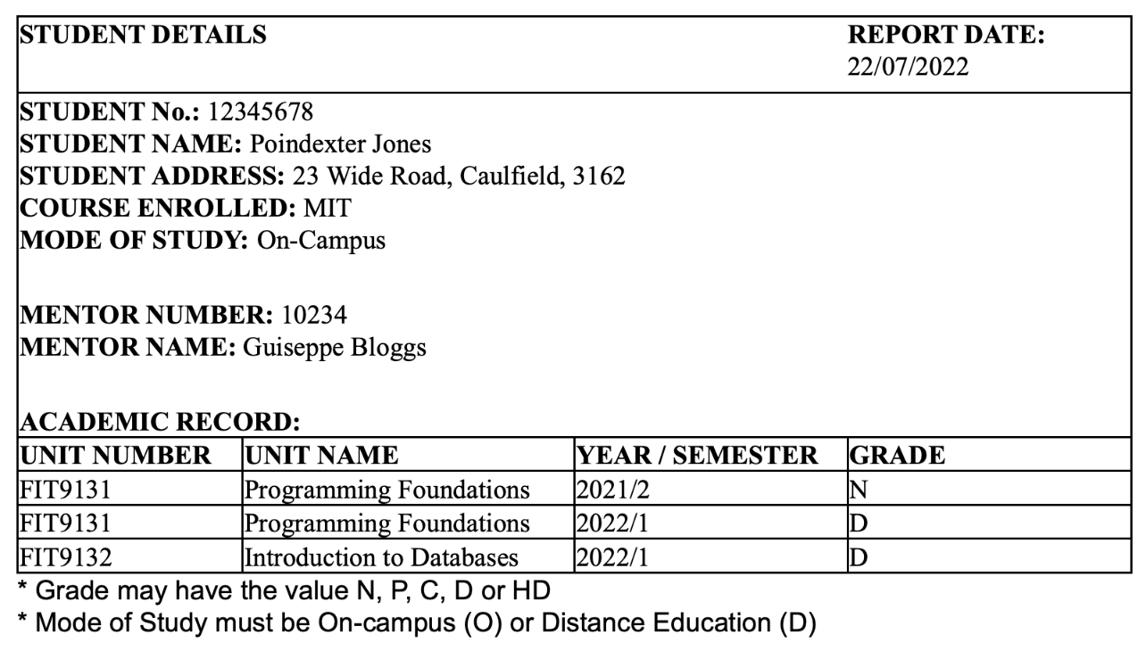
Normally we include all attributes in the form/report, but the report date in following reports is not an attribute that should be included in the normalisation process since it only represents the date when the report was printed. Also note that in this scenario unit name and unit description are not unique.
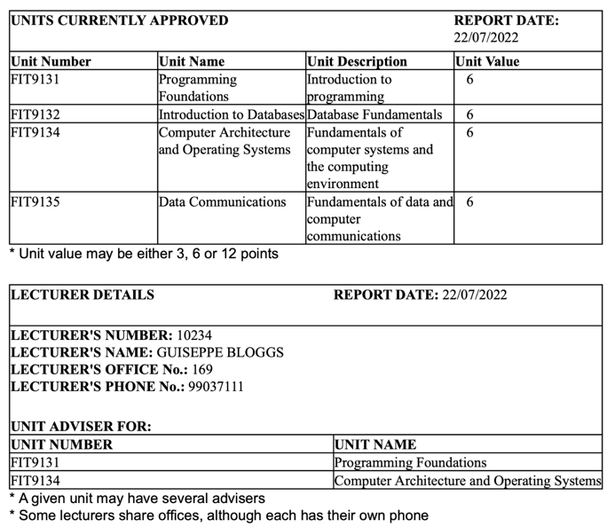
In order to add a student, the lecturer who advises that student must already exist in the database. No lecturer who advises any students may be deleted from the database. If the lecturer number of a lecturer is changed, then the number would be changed for each student advised by that lecturer.

APPROVED UNIT REPORT
UNF:
UNIT(unit_no, unit_name, unit_desc , unit_value)

1NF:
UNIT(unit_no, unit_name, unit_desc, unit_value)

CANDIDATE KEY:
unit_number

PARTIAL DEPENDENCY:
NONE

2NF:
UNIT(unit_no, unit_name, unit_desc, unit_value)

TRANSITIVE DEPENDENCY:
NONE

3NF:
UNIT(unit_no, unit_name, unit_desc, unit_value)
FULL DEPENDENCY:
unit_no -> unit_name, unit_desc, unit_value

LECTURER REPORT
UNF:
LECTURER(lect_no, lect_name, lect_office, lect_phone, (unit_no, unit_name)
1NF:
LECTURER(lect_no, lect_name, lect_office, lect_phone)
CK
- lect_no
- lect_phone
ADVICE(unit_no, unit_name, lect_no)
CK
- (unit_no, lect_no)
PARTIAL DEPENDENCY:
unit_no -> unit_name
2NF:
LECTURER(lect_no, lect_name, lect_office, lect_phone)
ADVICE(unit_no, lect_no)
UNIT(unit_no, unit_name)

TRANSITIVE DEPENDENCY:
NONE

3NF:
LECTURER(lect_no, lect_name, lect_office, lect_phone)
ADVICE(unit_no, unit_name, lect_no)
UNIT(unit_no, unit_name)
FULL DEPENDENCY:
lect_no -> lect_name, lect_office, lect_phone

unit_no -> unit_name

STUDENT REPORT
UNF
STUDENT(stu_no, stu_name, stu_address, stu_course, stu_mode, lect_no, lect_name, (unit_no, unit_name, ar_year, ar_sem, ar_grade))
1NF:
STUDENT(stu_no, stu_name, stu_address, stu_course, stu_mode, lect_no, lect_name)
CK
- stud_no

AC_REC(unit_no, ar_year, ar_sem, ar_grade, stu_no, unit_name)
CK
- unit_no, stu_no, ar_year, ar_sem
Partial dependency
unit_no -> unit_name
2NF:
STUDENT(stu_no, stu_name, stu_address, stu_course, stu_mode, lect_no, lect_name)
AC_REC(unit_no, ar_year, ar_sem, ar_grade, stu_no)
UNIT(unit_no, unit_name)
TRANSITIVE DEPENDENCY:
lect_no -> lect_name
3NF:
STUDENT(stu_no, stu_name, stu_address, stu_course, stu_mode, lect_no)
AC_REC(unit_no, ar_year, ar_sem, ar_grade, stu_no)
UNIT(unit_no, unit_name)
LECTURER(lect_no, lect_name)
FULL DEPENDENCY
stu_no -> stu_name, stu_address, stu_course, stu_mode, lect_no
unit_no, ar_year, ar_sem, stu_no -> ar_grade
unit_no -> unit_name
lect_no -> lect_name

